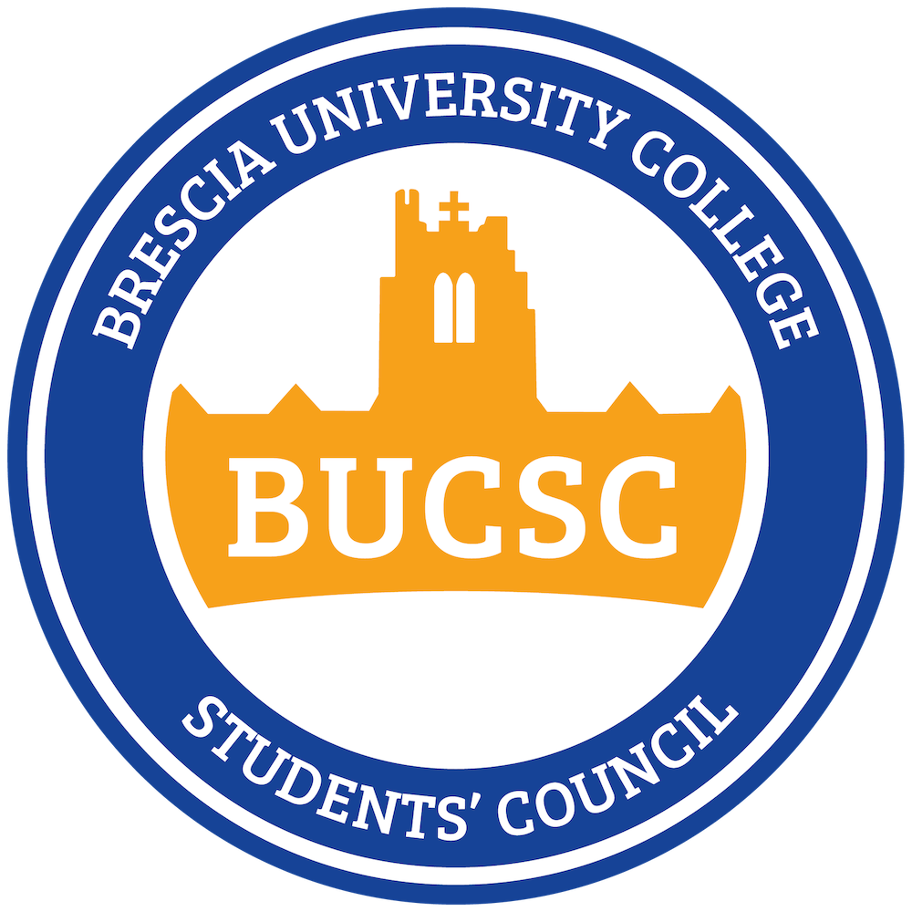
Applications for this Grant will be reviewed by the BUCSC Finance Committee. The committee meets every three weeks and review the applications at scheduled meetings. Applications can be submitted through the Clubs’ page of the BUCSC website (https://www.bucsc.ca/clubs)

Brescia University College Students’ Council

Clubs’ Initiative Grant Application 2020-2021
Applicant Information
Name
Contact Email
Club Name
Position in Club
Requested Amount

Application Questions
- Description of the group/organization’s mission and mandate (if applicable).

- Description of the conference, workshop, or other extracurricular academic opportunity.

- Verification of the amount of funding being requested, and when the funding will be required.

- An explanation of the funding shortfall and list of other funding sources already approached.

- Description of the benefits of participation in this conference, workshop or other extracurricular academic opportunity.

- Any other relevant information (e.g. Why should the BUCSC fund this event?)

