Brescia University College Students’ Council

Graphics and Branding Procedure
___________________________________________________________________________
EFFECTIVE: November 2017 SUPERSEDES: N/A

AUTHORITY: Council RATIFIED BY: Council as of 2017
___________________________________________________________________________
RELATED DOCUMENTS: BUCSC Poster Policy,Executive Terms of Reference
Page 1 of 3 ______________________________________________________________________________

PREAMBLE
The Brescia University College Students’ Council’s (BUCSC) Graphics and Branding Procedures provide support for those using the BUCSC logo, colours and name to create communication materials that present a clear and memorable impression of the BUCSC.

This procedure took inspiration from Western’s University Students’ Council Branding and Logo Usage Standards & Guidelines and the Brescia University College Graphic Standards Manual.

If you have any suggestions or questions, please feel free to email the Chief Communications Officer (CCO) at communications@bucsc.ca.

1. SCOPE

1.1 This document articulates the standards and guidelines of using the BUCSC brand, which includes, but is not limited to: its logo and affiliated logos and graphics.

2. DEFINITIONS

2.1 “Mediaform” is an online form which all anyone from the Brescia Community can fill out giving permission for the BUCSC to promote their events.

2.2 “Affiliate Organizations” include but are not limited to BUCSC ratified clubs and the Soph-Peer Mentor Team.

2.3 “Translucent” means the logo can be see-through while watermarking photos taken and owned by the BUCSC.

2.4 “Opaque” means the logo can be solid in colour and therefore not see-through while watermarking photos taken and owned by the BUCSC.

3. GENERAL

3.1 All members in the BUCSC and affiliate organizations shall adhere to these guidelines when creating and using BUCSC branding for communications purposes.

4. LOGO

4.1 The BUCSC circular logo to be used with explicit permission from the CCO of the BUCSC:
- The logo should never be manipulated or redrawn in anyway. However, sizing can be manipulated;
- The logo’s true form is most effective on a white background.
- The logo can be reproduced in black and white, but otherwise true colours are to be used.

5. BUCSC BRAND AND LOGO COLOURS

5.1 The BUCSC logo is built upon two colours, orange and blue:
- Orange: PMS 138, RGB R=247 G=161 B=26, HTML F7A11A;
- Blue: PMS 2738, RGB R=22 G=67 B=151, HTML 164397;

5.2 The full-colour logo is the preferred application. The logo may also be printed or used in black and white.

6. USAGE

6.1 Advertising:
- Must always follow BUCSC Graphics and Branding Procedures;
- All BUCSC advertising shall be created by the CCO and or AVP Promotions unless stated otherwise in the Mediaform;
  - The CCO is explicitly permitted to change or update the Mediaform;
- Advertising for affiliated organizations must include the BUCSC logo and be approved by the CCO and AVP Promotions.
- Brescia University College’s events do not need the BUCSC logo if no monetary compensation, sponsorship or partnership has taken place.

6.2 Photography:
- The BUCSC logo can be used on photographs. The logo is to be placed in the bottom right-hand corner of the photo in full colour, either with or without the white background behind the watermark. The logo can be translucent or opaque;
- Simple watermark of “Brescia University College Students’ Council” can also be used on photography at the discretion of the CCO.

6.3 Letterhead:
- Letterhead is to follow these branding procedures, with no adjustments unless explicitly prescribed by CCO.
- Documents and policies written by the BUCSC are to be structured in strict format. Please refer to Appendix A for further clarification:
  - The BUCSC logo is to appear in the top left-hand corner of every page in the document;
  - The whole document is to be in Helvetica in 12pt font with the exception of the title of the document which is to be in 16pt font.
  - All margins are standard (2.54cm bottom, left and right) with the exception of the top being 2cm).

APPENDIX A

Outline for the top of every document and policy by the BUCSC on the first page. 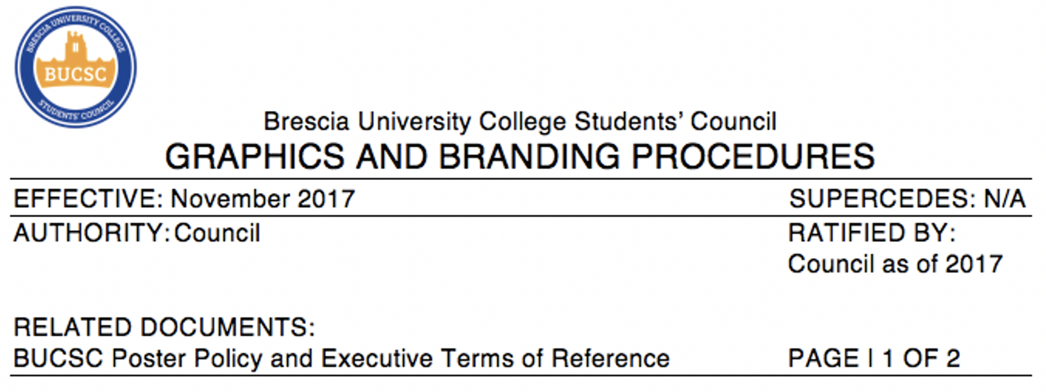
Outline for the top of every page with the exception of the first page of a document and policy written by the BUCSC.

